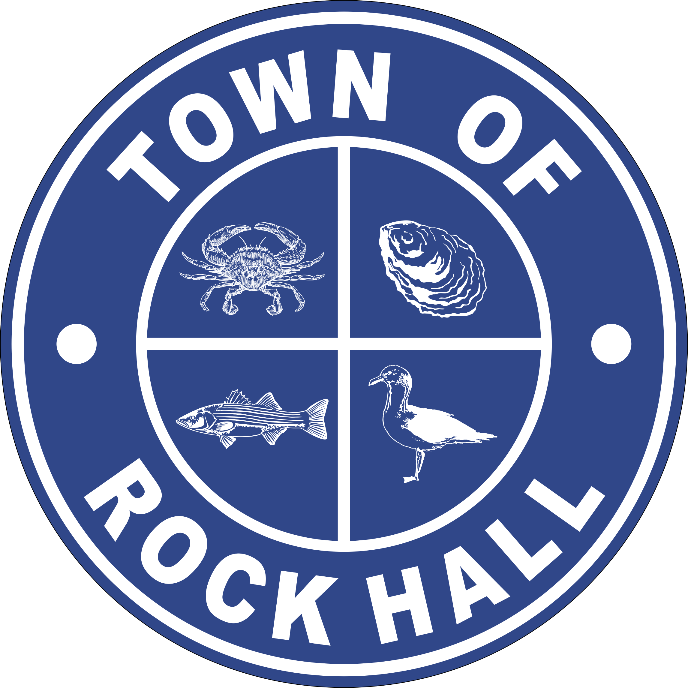

MAYOR & COUNCIL

REGULAR BUSINESS MEETING MINUTES

April 8, 2021
***Meeting minutes are transcribed in a summarized format. For full discussion and further detail of the meeting you can view the streamline video at the following link: http://townhallstreams.com/locations/rock-hall-md.
They are also available at Town Office***

Mayor Jacobs called the meeting to order at 6:06 p.m. In attendance were Vice Mayor Andrews, Councilmember Jones, Councilmember Edwards, Councilmember Collyer, Town Manager Resele, and Police Chief Dempsey.

Agenda

Vice Mayor Andrews made a motion to approve the agenda as presented. Councilmember Edwards seconded the motion. All in favor. Motion carried.

Swearing in of New Board Member

Robert Dunlap was sworn in a member of the Ethics Committee.

Minutes

Vice Mayor Andrews made a motion to approve the Regular Business Meeting Minutes for March 11, 2021. Councilmember Edwards seconded the motion. All in favor. Motion carried.

Vice Mayor Andrews made a motion to approve Closed Session Meeting Minutes for March 11, 2021. Councilmember Edwards seconded the motion. All in favor. Motion carried.
Presentation of FY20 Audited Financial Statements

Robert Diss from Lindsey & Associates presented his report on the FY20 audit.

Mayor’s Annual Report – May 2010 through March 2021

Mayor Jacobs read her report and is attached.

COVID-19 Challenge

Kent County has 30 new cases and the total to date is 125 cases in the 21661-zip code. The positively rate in Kent County is at 3.39%.

Per the State, anyone over the age of 16 can get the vaccine. The Kent County Health Department is using 18 and older.

Correspondence

Main Street Rock Hall gave an update on the Community Legacy Façade Improvement Projects.

Letter from Mr. Whitman about signage on Rt. 20 and Mercer Avenue will be tabled until the election.

Administrative Reports

Town Manager gave the Financial report. (*)
Police Chief Dempsey gave the police report. (*)

Streets and Sanitation

Patch repair estimate came back and the low bid was from Coppage Paving at $10,348.00.

Vice Mayor Andrews made a motion to approve the road repairs in the amount of $10,348.00. Councilmember Edwards seconded the motion. All in favor. Motion carried.
Price for shutoff valve on Sharp Street and Chesapeake Avenue is $4,086.54.

Vice Mayor Andres made a motion to approve the shutoff valve on Sharp Street and Chesapeake Avenue in the amount of $4,086.50. Councilmember Edwards seconded the motion. All in favor. Motion carried.

Water and Sewer Operations

Town Manager Resele read the Water and Sewer Plant monthly report which is attached.

Sewer Plant

Sent the State the SSO report for the spillage.

All three RAS pumps up and running.

Rebuilding the dry beds.

Air Compressor is out for repairs

Water Plant

Resolved the inconsistent readings on the Chemical feed.

Coyne Chemical will train staff on lab sampling process.

Parks & Recreation

Easter Egg Hunt was a success.

Ball fields are getting ready with the help of Councilmember Edwards.

Had a meeting and discussed the 4th of July festivities,

Councilmember Jones made a motion to approve the Parade and Fireworks on July 3, 2021 with approval from the Kent County Health Department. Vice Mayor Andrews seconded the motion. All in favor. Motion carried.
Planning and Zoning

Copies of the monthly report were handed out to the Council.

The Next Meeting will be held on April 14, 2021 with plans on discussing text amendments.

Mayor Jacobs along with Town Manager Resele, Liaison Andrews, Clerk-Treasurer Loller had a meeting with the Planning & Zoning Administrator about the turnaround time with permits and other zoning matters. Mayor Jacobs also discussed the commitment to update the Codes and Maps on the Town’s website.

Museum Board

MHAA grant ranked Rock Hall #2 out of 35 applicants and will go to the State level.

Mayor Jacobs talked about the MoMs Program (Museum on Mainstreet) and wants to apply.

Vice Mayor Andrews made a motion that the Museum Board move ahead with the MOM application. Councilmember Collyer seconded the motion. All in favor. Motion carried.

Communication Board

Nothing to report.

Transportation

There was a discussion about the refunded deposit money from the trolly and where it should go.

Councilmember Jones made a motion to transfer $4,940.00 from the General Fund to Transportation Fund to make it an even $12,000.00 in that account. Councilmember Collyer seconded the motion. All in favor. Motion carried.

Other Organization

Fireworks set for Saturday, July 3, 2021 at 9:15pm.

Special Events Permit

Vice Mayor Andrews made a motion to approve the Circus with corrected dates. Councilmember Edwards seconded the motion. All in favor. Motion carried.

Councilmember Collyer made a motion to approve the Kent County Library 3 events on June 21, 2021, July 15, 2021 and August 20, 2021. Vice Mayor Andrews seconded the motion. All in favor. Motion carried.

Vice Mayor Andrews made a motion to approve the Maggie’s Block Party on May 1, 2021. Councilmember Collyer seconded the motion. All in favor. Motion carried. Councilmember Jones abstained.

Councilmember Collyer made a motion to approve the Lion’s Club Yard Sale on September 17th and 18th 2021. Councilmember Edwards seconded the motion. All in favor. Motion carried.

Old Business

Resolution of Line of Credit

Waiting on the Bank to review.

Vote on Charter Amendment Resolution – Council Member Residency

Councilmember Collyer made a motion to approve the Charter Amendment Resolution No. 2021-01. Vice Mayor Andrews seconded the motion. All in favor. Motion carried.

NLC Service Line Warranty Program

Nothing new.

Sustainable Community Program Status

Approved for the next 5 years with the ability to amend due to COVID. Town Manager Resele and Liaison Collyer are working with the group for possible amendments when they are able to meet together face to face.

Think Big

Should be able to connect in the next 2 weeks.

Grants

Mayor Jacobs stated that the Town will receive Capital Funding of $250,000.00 for the Town Hall roof repairs from the State Capital Budget line-item funding obtained for the Town by Delegate Jacobs, Delegate Ghrist and Senator Hersey.

New Business

Hotel Tax Revenue

There was a discussion and will be talked about at a later date.

Kirwan Commission

Mayor Jacobs stated that the Kirwan Legislation was passed at the State level and if something is not done to rebate the County for its increased cost for public school education, there could be a possible 30% increase to the County real estate tax.

FYI

Municipal Election will be held on May 1, 2021 from 10am -8pm at the Town Hall.

Next Meeting Dates

Monday, May 3, 2021 – Utilities Board Meeting and Mayor & Council Regular Workshop Meeting.

Thursday, May 13, 2021 – Mayor & Council Regular Business Meeting.
Special Workshops – if needed - TBD
CDBG Income Survey
Re-purpose MD-HCD Grants Fund
Utility Fund Revenue Considerations
FY2022 Budget

Special Thank You

The Council thanked Vice Mayor Andrews on her last night on Council.

Adjournment

Motion to adjourn the Regular Business Meeting at 9:26 p.m. was made by Vice Mayor Andrews. Councilmember Edwards seconded the motion. All in favor. The motion carried.

(*) See Town Manager’s, Financial and the Police Report for further details.

Respectfully Submitted:

______________________________
Cheryl M. Butler

Approved by:

______________________________
Dawn Jacobs, Mayor

_______________________________
Beth Andrews, Vice Mayor

______________________________
Carolyn Jones, Councilmember

______________________________
Timmy Edwards, Councilmember

______________________________
Eleanor Collyer, Councilmember

