MAYOR & COUNCIL

REGULAR BUSINESS MEETING MINUTES

February 11, 2021
***Meeting minutes are transcribed in a summarized format. For full discussion and further detail of the meeting you can view the streamline video at the following link: http://townhallstreams.com/locations/rock-hall-md.
They are also available at Town Office***

Mayor Jacobs called the meeting to order at 6:00 p.m. In attendance were Vice Mayor Andrews, Councilmember Edwards, Town Manager Resele and Police Chief Dempsey. Councilmember Jones and Councilmember Collyer attended the meeting virtually.

Agenda

Vice Mayor Andrews made a motion to approve the agenda as amended. Councilmember Edwards seconded the motion. All in favor. Motion carried.

Councilmember Collyer made a motion to nominate Mary Sue Willis to the Museum Board. Vice Mayor Andrews seconded the motion. All in favor. Motion carried.

Vice Mayor Andrews made a motion to nominate Jeff Guthrie to Planning & Zoning. Councilmember Collyer seconded the motion. All in favor. Motion carried.

Swearing in of New Board Members

Museum Board:
Cathy Bramble
Courtney Chipouras
Sawyer Cornelius
Andy Glenn
Marta McCave
Terri Mullikin
Timmy Price
Chrissy Price Stickland
Tot Strong
Melanie Trego
Mary Sue Willis

Planning & Zoning:
Jeff Guthrie

Planning & Zoning Board of Appeals:
Laurie Resele
Peter Sorrenson

Mayor Jacobs made a motion to recess to the Public Hearing. Councilmember Jones seconded the motion. All in favor. Motion carried.

Minutes

Vice Mayor Andrews made a motion to approve the Regular Business Meeting Minutes for January 14, 2021. Councilmember Collyer seconded the motion. All in favor. Motion carried.

Vice Mayor Andrews made a motion to approve Closed Session Meeting Minutes for January 14, 2021. Councilmember Jones seconded the motion. All in favor. Motion carried.

Vice Mayor Andrews made a motion to approve the Special Workshop Meeting Minutes for January 21, 2021. Councilmember Jones seconded the motion. All in favor. Motion carried.

Vice Mayor Andrews made a motion to approve Closed Session Meeting Minutes for January 21, 2021. Councilmember Collyer seconded the motion. All in favor. Motion carried.

COVID-19 Challenge

Kent County has had 1073 cases to date and 122 cases in the 21661-zip code. The only vaccination place in Kent County will be at the Worton at the Community Center provided by the Kent County Health Department.

Correspondence

Letter from the Main Street Rock Hall Committee was read and there was a brief discussion.

Administrative Reports

Police Chief Dempsey gave the police report. (*)

Streets and Sanitation

Backhoe has been sent out for repairs. Will be using a rental until it is fixed.

Water and Sewer Operations

Town Manager Resele read the Water and Sewer Plant monthly report which is attached.

Sewer Plant

PS#4 – Pump #1 is out for repairs. Quote for repairs is $3,567.84

Vice Mayor Andrews made a motion to approve the repairs to PS#4 – Pump #1 for $3,567.84. Councilmember Collyer seconded the motion. All in favor. Motion carried.

DSi quoting two repairs for PS#2 valve replacement and the large volume pump in the WWTP basement.

PS#3 repaired and back on line.

Water Plant

Scott Getchell from GMB talked about the benefits and costs of Green Sand Plus vs. Filter Sand. A discussion followed.

Water shut off was discussed and it was decided to sent out letters to non-payment residents.

Parks & Recreation

Nothing to report.

Planning and Zoning

Nothing to report except there are a lot of little projects in the works.

Museum Board

The Board Members was to bring back the Museum Webpage.

Communication Board

Nothing to report.

Transportation

Nothing to report.

Other Organization

The Rock Hall Business Association is working on the new events brochure calendar.

Old Business

Vote on Ordinance No. 2021-01 and 2021-02

Vice Mayor Andrews made a motion to approve Ordinance No. 2021-01. Councilmember Edwards seconded the motion. All in favor. Motion carried.

Vice Mayor Andrews made a motion to approve Ordinance No. 2021-02. Councilmember Jones Seconded the motion. All in favor. Motion carried.

Introduction of Ordinance No. 2021-05

The Authorization of General Obligation Refunding Bonds

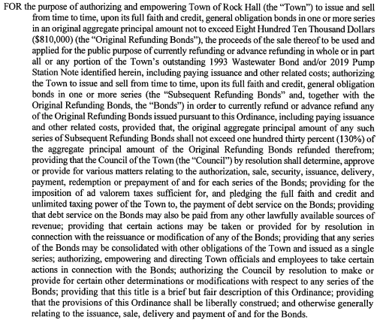

Introduction of Ordinance No. 2021-04

The Authorization of General Obligation Bonds, Bond Anticipation Notes and Refunding Bonds for the Water Meter System Upgrade Project

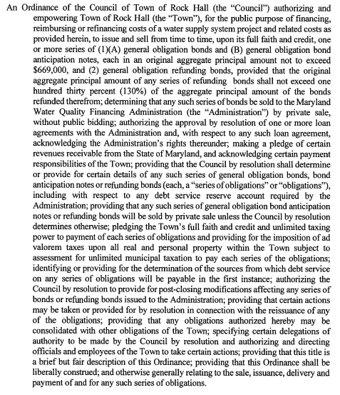

Introduction of Ordinance No. 2021-03

The authorization of General Obligation Bonds, Bond Anticipation Notes and Refunding Bonds for the Two Roof, the Headworks System, and the Horizontal Filter Projects Identified Herein, Together with Related Costs

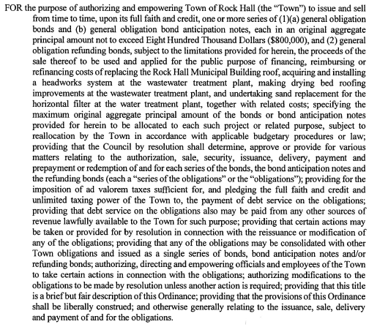

Resolution of Line of Credit

Tabled until next meeting.

Discuss Proposed Charter Amendment – Council Member Residency

There was discussion and there are still a few things that need to be addressed in the wording.

Personnel Policy

Slowly progressing

Status of Grants

Re- Purpose MD-HCD Grant Fund – Still have not heard back from them.

NLC Service Line Warranty Program

There was a discussion.

Vice Mayor Andrews made a motion to allow NLC Service Line Warranty Program to solicit their services to the Town Residents. Councilmember Collyer seconded the motion. All in favor. Motion carried.

Establishment of Ethics Committee

Tabled until a Special Workshop Meeting.

New Business

Asset Management Software (CMMS)

After a discussion

Vice Mayor Andrews made a motion to give the Town Manager Robert Resele the authority to spend up to $7,540.00 for first year cost for the Asset Management Software Program. Councilmember Collyer seconded the motion. All in Favor. Motion carried.

Next Meeting Dates

Monday, March 1, 2021 – Utilities Board Meeting and Mayor & Council Regular Workshop Meeting.

Thursday, March 11, 2021 – Mayor & Council Regular Business Meeting.

Special Workshops – if needed - TBD
CDBG Income Survey
Re-purpose MD-HCD Grants Fund
Utility Fund Revenue Considerations
FY2022 Budget

Closed Session

Vice Mayor Andrews made a motion to recess into closed session at 8:39 p.m. under General Provisions Art. 3-305(b)(1) “to discuss the appointment, employment, assignment, promotion, discipline, compensation, removal, resignation, or performance evaluation of appointees, employee, or officials over whom this public body has jurisdiction; any other personnel matter that affects one or more specific individuals”. And 3-305(b)(8) “to consult with staff, consultants, or other individuals about pending or potential litigation”. Councilmember Edwards seconded the motion. All present in favor. Motion carried.

There were no actions Taken in Closed Session.

Adjournment

Motion to adjourn the Regular Business Meeting at 8:48 p.m. was made by Vice Mayor Andrews. Councilmember Edwards seconded the motion. All in favor. The motion carried.

(*) See Town Manager’s, Financial and the Police Report for further details.

Respectfully Submitted:

______________________________
Cheryl M. Butler

Approved by:

______________________________
Dawn Jacobs, Mayor

_______________________________
Beth Andrews, Vice Mayor

______________________________
Carolyn Jones, Councilmember

______________________________
Timmy Edwards, Councilmember

______________________________
Eleanor Collyer, Councilmember

