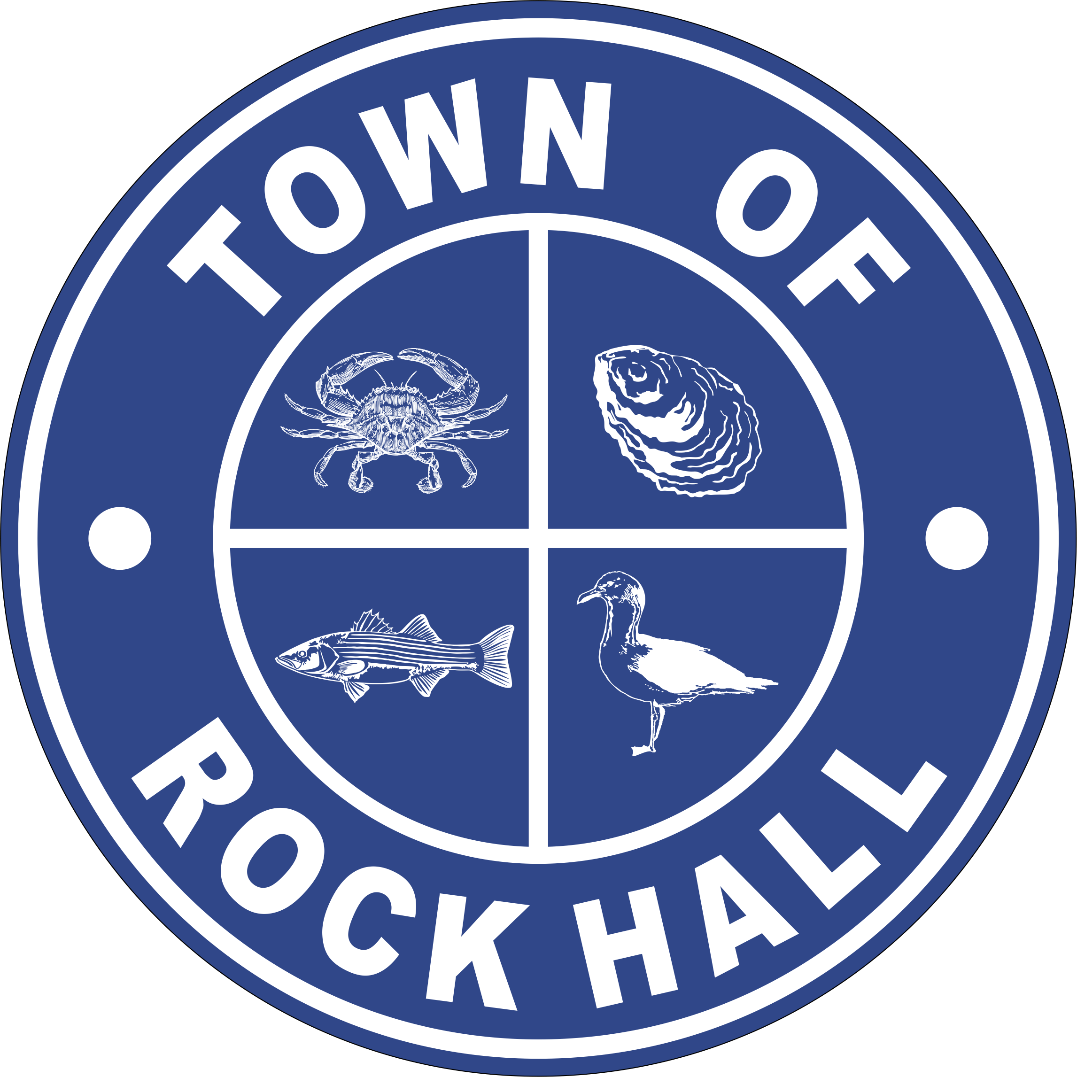

MAYOR & COUNCIL

REGULAR BUSINESS MEETING MINUTES

February 10, 2022
***Meeting minutes are transcribed in a summarized format. For full discussion and further detail of the meeting you can view the streamline video at the following link: http://townhallstreams.com/locations/rock-hall-md.
They are also available at Town Office***

Mayor Jacobs called the meeting to order at 6:02 p.m. In attendance were Vice Mayor Jones, Councilmember Cook, Councilmember Edwards, Councilmember Collyer, Town Manager Resele and Police Chief Dempsey.

Agenda

Vice Mayor Jones made a motion to approve the agenda as amended. Councilmember Cook seconded the motion. All in favor. Motion carried.

Minutes

Councilmember Cook made a motion to approve the Regular Business Meeting Minutes for January 18, 2022 with corrections. Councilmember Edwards seconded the motion. All in favor. Motion carried.

Councilmember Cook made a motion to approve the Closed Session Meeting Minutes from January 18, 2022. Vice Mayor Jones seconded the motion. All in favor. Motion carried.

Speaker Request – Kent County Library Executive Director Arnessa Dowell

Reported that the Rock Hall Library Branch re-opened in December and they will be adding another day to be open which will be Friday’s starting in March. Talked about the success in recent programs provided by the library and asked the Council to consider financial support when preparing the Budget.

Correspondence

Main Street Rock Hall sent in their January/February Newsletter.

Administrative Reports

The Financial Report.

Police Chief Dempsey gave the police report.

Chief Dempsey discussed the obscene sign on Judefind Avenue which had numerous complaints. The sign had since been removed.

Streets and Sanitation

Snow removal.

Truck in for service – repaired and back in service.

Worked with Water Main breaks and Pump Station #2 repairs.

AMI Meter installations on going.

Water Operations

New meters locating many home/businesses water leaks.

Need to complete water main road work on Route #20.

Sewer Plant Operations

Waiting on tiles for drying beds.

Polymer pump not operating, Tear down of pump to fine problem.

Parks & Recreation

Next Meeting will by Monday, February 21, 2022 at 7:00 pm.

Planning and Zoning

Chris Jakubiak, Planning and Zoning Administrator attended the meeting virtually.

Town Manager Resele conducted two interviews for Code Enforcer with two more to be interviewed.

The Public Hearing on February 9, 2022 on the Critical Area Map went well with no public opposition.

Board of Appeals hearing will be sometime in March.

Museum Board

Mayor Jacobs asked the Council to reconsider Mr. Forloney’s contract and the RFP that was not voted on correctly.

Mayor Jacobs stated that the $19,894.00 Museum Board contract was fully funded by sources other than Town taxes.

Councilmember Cook made a motion to approve Mr. Forloney’s proposal for Phase II of the Museum Board Planning Strategy. Vice Mayor Jones seconded the motion. Mayor Jacobs, yes, Councilmember Cook, yes, Vice Mayor Jones, yes, Councilmember Edwards, no, Councilmember Collyer, abstention. Vote carried.

Councilmember Cook made a motion to approve the Contract for consulting services for Phase II of the Museum Board Planning Strategy project between the Town of Rock Hall and Mr. Forloney. Vice Mayor Jones seconded the motion. Mayor Jacobs, yes, Councilmember Cook, yes, Vice Mayor Jones, yes, Councilmember Edwards, no, Councilmember Collyer, abstention. Vote carried

Communication Board

Carol Britten has started working on the visitor page information on the Town website.

Transportation

Nothing to report.

Ethics Board

Councilmember Collyer reported that the three prospective Ethics Board Members almost ready for Council consideration.

Other Organization

The Rock Hall Volunteer Fire Company will not be having the Bike Fest this year.

Special Events Permit

Lion’s Club will be having the Circus on May 6th with location to be determined.

Old Business

American Rescue Plan

Town Manager Resele reported on the spending allocations.

Town Hall Update

Quote to have survey of old Town Hall - $700 to mark corners and $1700 to do complete with building on document.

Councilmember Collyer made a motion to approve the $1,700.00 to survey the Town Hall property lines. Councilmember Edwards seconded the motion. All in favor. Motion carried.

Mayor Jacobs updated the status of possible State and Federal earmark funds for the Town Hall repair or replacement.

CDBG Grant: Haven Water Main waiting for approval to spend. Engineering Survey starts tomorrow February 11, 2022.

USDA Grant: equipment waiting for closing of project.

School Vest Grant: need new quotes to complete – Due by April

PBI walkthrough on Town Hall – January 12, 2022 report reviewed with Building Advisory Committee on Monday. They will be reviewing new calculations and will comment but might need a Special Workshop meeting.

New Business

Council Proclamation – Covid Frontline Workers Appreciation

Mayor Jacobs read the Proclamation.
COVID-19 FRONTLINE RESPONDER DAY
WHEREAS, COVID-19 is a global threat to our health and safety, and the result of more than 733,000 deaths in the United States; and

WHEREAS, Our community has experienced the effects of the COVID-19 global pandemic, and has dramatically impacted our community and increased the burden shouldered by our local Public Health department, first responders, hospital staff, and those working in our congregate care facilities; and

WHEREAS, Those who chose service in public safety, healthcare, and caregiving as their life’s work serve their communities with a reverence for human life and individual dignity, and are dedicated to relieving pain and suffering, even more so during this pandemic; and
WHEREAS, Our community receives care from these devoted public servants despite daunting challenges brought on by the COVID-19 global pandemic while risking their own lives and the well-being of their own families.

NOW, THEREFORE, We, The Mayor & Council of the Town of Rock Hall, Maryland, do hereby proclaim February 14, 2022 as “COVID-19 FRONTLINE RESPONDER DAY” in Rock Hall and do commend this observance to all Rock Hall Town Citizens.

THE MAYOR & COUNCIL
OF ROCK HALL, MARYLAND

Councilmember Cook asked is the Town Attorney would review his proposal on the possible Town tax on property transfers. Council approved.

Donation to Public Works $20,000 – request to go for the purchase snowplow, accessories and the remaining for the down payment of new truck. Check received from John Buckley & Kathy L. Leasure.

Councilmember Cook made a motion that the $20,000.00 donation be put towards the purchase of a snow plow and the rest be allocated towards the down payment of the Truck. Vice Mayor Jones seconded the motion. All in favor. Motion carried.

Trade in a Police vehicle for $900, can be a car for new Code Enforcement Officer.

Grant application for Pump Station #2 sent in on Monday February 7, 2022 for $834,500

Amended School Board MOU needs to be signed by the Council.

Councilmember Collyer made a motion to approve the 1at amendment of the MOU with the Kent County Board of Education with regard to the Police Department being held in the Rock Hall Elementary School. Vice Mayor Jones seconded the motion. All in favor. Motion carried.

ARPA funding for Water Towers – Meeting with Southern Corrosion on February 15, 2022.

Need to Start new CDBG Application for Water Mains.

For the Good of the Town

Ed Hatcher and Mark Einstein spoke.

Next Meeting Dates
Monday, February 28, 2022 – Utilities Board Meeting and Mayor & Council Regular Workshop Meeting.

Thursday, March 10, 2022 – Mayor & Council Regular Business Meeting.

Special Workshops if needed – TBD
Town Hall Building discussions/plans

Closed Session

Councilmember Collyer made a motion to recess into closed session at 8:13 p.m. under General Provisions Art. 3-305(b)(1) “to discuss the appointment, employment, assignment, promotion, discipline, compensation, removal, resignation, or performance evaluation of appointees, employee, or officials over whom this public body has jurisdiction; any other personnel matter that affects one or more specific individuals”. Councilmember Edwards seconded the motion. All in favor.

Actions taken:

None

Adjournment
Motion to adjourn the Regular Business Meeting at 9:56 p.m. was made by Vice Mayor Jones. Councilmember Collyer seconded the motion. All in favor. The motion carried

Respectfully Submitted:

______________________________
Cheryl M. Butler

Approved by:

______________________________
Dawn Jacobs, Mayor

_______________________________
Carolyn Jones, Vice Mayor

______________________________
Timmy Edwards, Councilmember

______________________________
Eleanor Collyer, Councilmember

______________________________
James Cook, Councilmember

