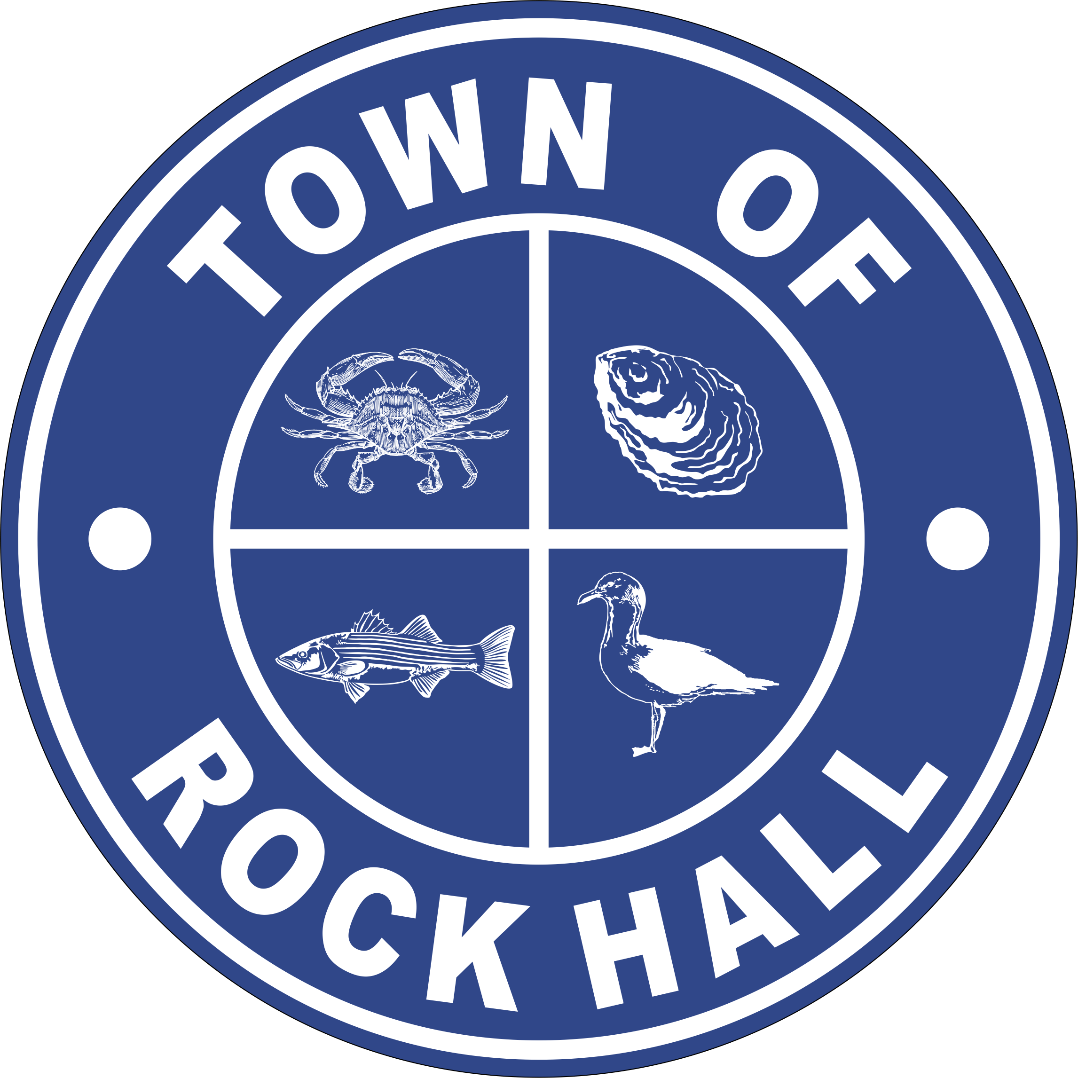

MAYOR & COUNCIL

REGULAR BUSINESS MEETING MINUTES

May 12, 2022
***Meeting minutes are transcribed in a summarized format. For full discussion and further detail of the meeting you can view the streamline video at the following link: http://townhallstreams.com/locations/rock-hall-md.
They are also available at Town Office***

Mayor Jacobs called the meeting to order at 6:07 p.m. In attendance were Vice Mayor Jones, Councilmember Edwards, Councilmember Collyer, Councilmember Cook, Town Manager Resele, Clerk-Treasurer Loller and Police Chief Dempsey.

Agenda

Vice Mayor Jones made a motion to approve the agenda as amended. Councilmember Cook seconded the motion. All in favor. Motion carried.

Minutes

Councilmember Cook made a motion to approve the Regular Business Meeting Minutes for March 10, 2022. Vice Mayor Jones seconded the motion. All present in that meeting in favor. Motion carried.

Councilmember Cook made a motion to approve the Closed Session Meeting Minutes from March 10, 2022. Councilmember Edwards seconded the motion. All present at that meeting in favor. Motion carried.

Town Hall Discussion
Invited Participants:

Robert Forloney – Helping the Museum Board with Town of Rock Hall Interpretative Planning Project which is a formal procurement process, the Town of Rock Hall secured a qualified consultant to work with the Town, its Museum Board, and interested parties to conduct a comprehensive strategic planning process. This process will result in an interpretive plan that strives to revitalize the heritage infrastructure for the Town of Rock Hall. Successful completion will positively impact Rock Hall’s economy and provide opportunities for many Town residents.

Joe Sherren – Collections Specialist Consultant – He researches, develops and implements museum policies in collections stewardship, strategic planning, remediation and risk management. Joe stated that no two projects are the same when working with collections.

Susan White – SEC – Indoor Air Quality Consultant – Susan stated the hazard from the asbestos in the building. She said the conditions will worsen over the summer months. She also stated that N96 mask and gloves be worn when entering the building.

Gary Wah – Art Recovery – Gary estimates that if everything was packed and brought to Baltimore, stored and kept until ready to come back to Rock Hall, the full invoice might be close to $110,000.00.

Patrick Thomas – Town Attorney – Patrick cautioned against anyone entering the Town Hall building. If it is necessary to remove anything from the building, it should be done in coordination with the hazardous materials contractors following all safety and decontamination requirements.

Tia Bowmen and Matt Peter – Local Government Insurance Trust – They stated that any claim involving mold weather it’s a property claim to liability claim is exclude from coverage. No coverage from LGIT if legal action from mold is brought to the Town.

Tot Strong – Chairman, Rock Hall Museum Board – Tot stated that the Council has to decide what is going to be done with the Museum artifacts. He said there were three choices; mothball the building, disband it and give the artifacts back to their owners or clean, salvage and relocate. A discussion followed.

Swearing in Parks & Recreation Board Member

Mayor Jacobs swore in Patty Williams to the Parks & Recreation Board.

Correspondence

Mayor Jacobs shared a letter sent to the Delmarva Community Transit requesting the use of four buses during the Pirates & Wenches weekend held August 13-15th.

Mayor Jacobs shared the support letter to the County Commissioners in full support for the proposed funding in consideration of expanding transportation to Rock Hall and potentially to Chestertown and Tolchester this coming summer.
Main Street Committee stated they were in the process of applying for a $20,000.00 grant. There will be a ribbon cutting for the Village businesses on Friday, May 20th from 4-6 pm at the Gazebo by the corner of Main Street and Route 20.

Recognition of National Police Week

In 2022, the names of 619 officers killed in the line of duty were added to the National Law Enforcement Officers Memorial in Washington, DC. These 619 officers include 472 officers who were killed during 2021 (319 fatalities were COVID-19-related). An additional 147 officers died in previous years (before 2021). Many of their stories of sacrifice had been lost to history until now.

Mayor Jacobs thanked Chief Dempsey and his Officers for their service.

Administrative Reports

The Financial Report was tabled until Budget Workshop.

Police Chief Dempsey gave the police report. There was a conversation on a speed bump at Boundary Avenue and East Sharp Street.

Councilmember Cook made a motion to paint a line/stripe at the stop sign. Councilmember Collyer seconded the motion. All in favor. Motion carried.

Town Manager Resele to get prices on a flashing stop sign for an option later on.

Streets and Sanitation

AMI Meter installations are going on - 270 are now installed.

Filled 17 major pot holes but there are still more that need to be filled.

Maintenance Software for streets, pump stations and hydrants. Annual cost will be $2,200.00. Setup, GIS integration and Data Conversion fee will be $1,500.00. Total invoice will be $3,700.00.

Water Operations

2021 CCR Water Report from the State had been posting on website and in the Kent County News.

Hydrant Flushing this month or early June. Will notify residents beforehand.

Coyne to do testing of wells.

Sewer Plant Operations

OBT bearing replacement cost will be $3,122.45.

Councilmember Cook made a motion to approve the OBT bearing replacement in the amount of $3,122.45. Councilmember Edwards seconded the motion. All in favor. Motion carried.

Parks & Recreation

Looking for people to help with 4th of July. Please contact Donna Legg.

Planning and Zoning

Chris Jakubiak, Planning and Zoning Administrator introduced proposed amendments from Brad Medley of Medley’s Outdoor Escapes.

Comp Plan review and approved a schedule for completing the plan and steps to update the current plan. The Planning Commission would like to meet with the Council about what if any priorities they may have or ideas they might like the Commission to explore. The Commission would like to hear from the Council before getting to far into the public aspects of the plan.

Code Enforcement

Code Enforcer Whitman stated that the enforcement codes need to be updated and charged. Most of them were made back in the 70’s.

There are 40 open cases and 11 closed cases.

Museum Board

Mayor Jacobs asked for the original MHAA grant be approved.

Councilmember Cook made a motion to approve the grant application for MHAA. Councilmember Collyer seconded the motion. All in favor. Motion carried.

Councilmember Cook made a motion to authorize to get multiple bids from multiple contractors for packing and moving artifacts. Councilmember Collyer seconded the motion. All in favor. Motion carried.

Communication Board

Need to work on the .gov side of the webpage.

Transportation

Nothing to report.

Ethics Board

Nothing to report.

Other Organization

Nothing to report.

Old Business

Ordinance No. 2022-01 – Critical Area Overlay Map

Councilmember Cook made a motion to approve Ordinance 2022-01 Critical Area Overlay Map. Councilmember Collyer seconded the motion. All in favor. Motion carried.

American Rescue Plan

Mayor Jacobs and Town Manager Resele met with the Kent County Commissioners on May 3, 2022 about the rescue plan.

Town Hall Options Update

Councilmember Cook stated that there were 192 surveys returned back. Summary attached.

A discussion followed about some of the comments.

New Business

Charter Amendment Resolution No. 2022-01 – Ordinance re: Budget Adoption

Mayor Jacobs read the first paragraph from the Resolution.

A CHARTER AMENDMENT RESOLUTION OF THE COUNCIL OF THE TOWN OF ROCK HALL, MARYLAND, adopted pursuant to the authority of Article XI-E of the Constitution of Maryland and §§ 4-302(1) and 4-304 of the Local Government Article of the Maryland Annotated Code to amend the Municipal Charter of the Town of Rock Hall (as published in Chapter 125, Volume 7, Compilation of Municipal Charters) for the purposes of providing that ordinances, or parts thereof, passed under the authority of the Charter pertaining to levying property taxes for the payment of indebtedness, adoption of the annual budget, authorizing the annual tax levy, or levying special assessment charges, where the proceeds of such special assessment charges have been or are to be pledged to the payment of any bonds, notes, or other indebtedness incurred or to be incurred by the Town for public improvements to be financed in whole or in part by each special assessment charge, shall become effective on the date specified in the ordinance and may become effective immediately upon passage and providing that the Town’s annual budget shall be prepared and adopted in the form of an ordinance; providing that the title of this Charter Amendment Resolution shall be deemed a fair summary; and generally relating to ordinances of the Town of Rock Hall.

Resolution No. 2022-02 – SB RHL, LLC

A Resolution of the Council of the Town of Rock Hall approving an Enterprise Zone Tax Credit against the increase in Town and County taxes resulting from certain capital improvements to certain real property within the corporate limits of the Town of Rock Hall.

Councilmember Cook made a motion to approve Resolution No. 2022-02. Councilmember Collyer seconded the motion. All in favor. Motion carried.

Resolution No. 2022-03 – Gaels N Dons, LLC

A Resolution of the Council of the Town of Rock Hall approving an Enterprise Zone Tax Credit against the increase in Town and County taxes resulting from certain capital improvements to certain real property within the corporate limits of the Town of Rock Hall.

Councilmember Collyer made a motion to approve Resolution No. 2022-03. Councilmember Cook seconded the motion. All in favor. Motion carried.

Budget Workshop Schedule

After a discussion it was decided to have the first budget meeting on Wednesday, May 18, 2022 at 6:00 pm.

For the Good of the Town

Laurie Walters asked about the Pirates & Wenches weekend.

Councilmember made a motion as amended to request that Legal construct a legal guideline for the allowance of temporary parking of RV’s during the Town Special Events and limit the number of permits available. Vice Mayor Jones seconded the motion. All in favor. Motion carried.

Next Meeting Dates
Tuesday, May 31, 2022 – Utilities Board Meeting and Mayor & Council Regular Workshop Meeting.

Thursday, June 9, 2022 – Mayor & Council Regular Business Meeting.

Special Workshops if needed – TBD
Town Hall Building discussions/plans
Budget and Financing Discussions

Adjournment
Motion to adjourn the Regular Business Meeting at 9:07 p.m. was made by Councilmember Collyer. Vice Mayor Jones seconded the motion. All in favor. The motion carried

Respectfully Submitted:

______________________________
Cheryl M. Butler

Approved by:

______________________________
Dawn Jacobs, Mayor

_______________________________
Carolyn Jones, Vice Mayor

______________________________
Timmy Edwards, Councilmember

______________________________
Eleanor Collyer, Councilmember

______________________________
James Cook, Councilmember

