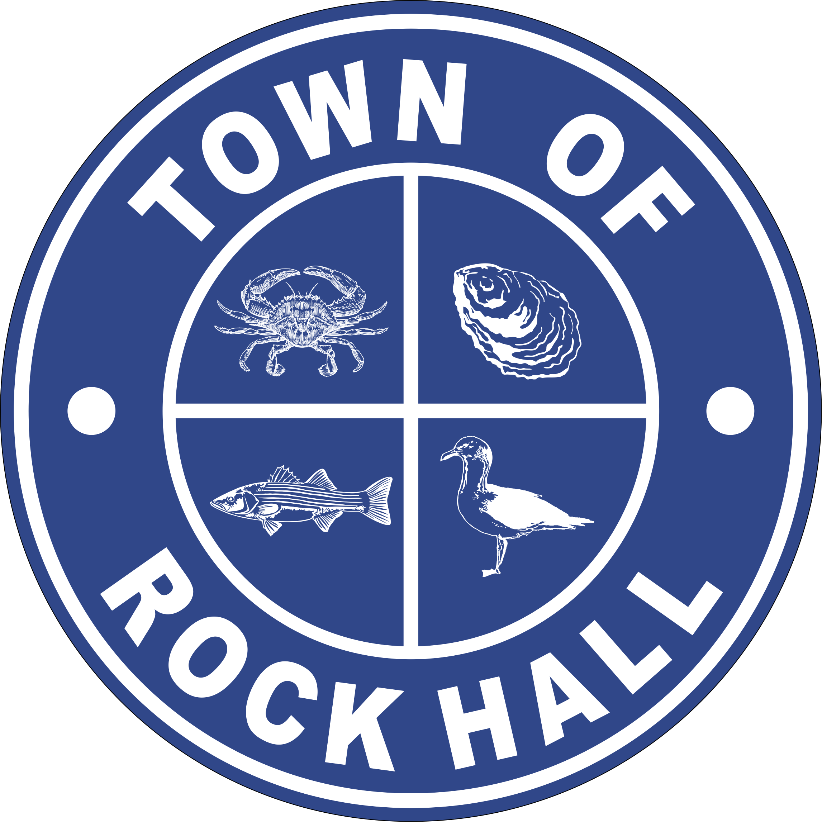

MAYOR & COUNCIL

REGULAR BUSINESS MEETING MINUTES

May 13, 2021
***Meeting minutes are transcribed in a summarized format. For full discussion and further detail of the meeting you can view the streamline video at the following link: http://townhallstreams.com/locations/rock-hall-md.
They are also available at Town Office***

Mayor Jacobs called the meeting to order at 6:00 p.m. In attendance were Vice Mayor Jones, Councilmember Cook, Councilmember Edwards, Councilmember Collyer, Town Manager Resele, Clerk-Treasurer Loller, and Police Chief Dempsey.

Agenda

Councilmember Collyer made a motion to approve the agenda as amended. Vice Mayor Jones seconded the motion. All in favor. Motion carried.

Recognition of Girl Scouts & Garden Club Joint Beautification Project

Mayor Jacobs thanked Taylor Mangels and Rory Walters for the work they did with the Garden Club.

Recognize Law Enforcement

Mayor Jacobs thanked the Police Officers for their outstanding performance throughout the year.

Minutes

Vice Mayor Jones made a motion to approve the Public Hearing Meeting Minutes for April 8, 2021. Councilmember Edwards seconded the motion. All in favor. Motion carried.

Councilmember Collyer made a motion to approve Regular Business Meeting Minutes for April 8, 2021. Vice Mayor Jones seconded the motion. All in favor. Motion carried.

Vice Mayor Jones made a motion to approve the Organizational Meeting Minutes for May 3, 2021. Councilmember Edwards seconded the motion. All in favor. Motion carried.

COVID-19 Challenge

Per Governor Hogan’s, restrictions are being lifted. No face mask will be required outdoors. Restaurants and outside venue compacity requirements will be lifted. Indoor face mask are still in place.

Correspondence

Mayor Jacobs was given approval to sign a letter of support for Stories of the Chesapeake.

Council approved a $50.00 donation to the Lions Club to purchase Circus Tickets for some children to attend.

Mayor Jacobs received an email about obscene political banners on private property. There was no action taken, but the Council agreed to not condone them.

Council approved the signing of a letter of support for Main Street Rock Hall for the application for an FY 2022 Operating Assistance Grant.

Administrative Reports

Clerk-Treasurer Loller gave the financial report. (*)
Police Chief Dempsey gave the police report. (*)

Streets and Sanitation

Opened Beach and addressed issues with water line and sand after fencing was take down.

Fixed sink hole at Chesapeake Avenue and repaired water leak on Ann Street.

Assisted installation of Security Cameras.

Assisted in installation of pipe line from WWTP to Lagoon.

Assisted in clean up and repair of drying beds and assisted DSi in the repair of Pump Station #2.

Working with construction company for Automated Meter installations.

Rental of excavator for Sewer piping is also being used to clean ditches - $1,700.00 per month needs approval.

Vice Mayor Jones made a motion to pay the $1,700.00 per month for the rental of the excavator. Councilmember Collyer seconded the motion. All in favor. Motion carried.

Water and Sewer Operations

Plant operation process running within control specifications.

Report on Manganese shows that plant is filtering to specs (<0.02 mg/L).

With clarifier producing a good blanket the Iron reading are below spec in Iron to distribution.

Construction continuing on Automated Meter Project

Sewer Plant

Compiling the 30-day report to MDE.

Cleaning digesters to repair Bubble Diffusers.
Running with all new engineering process specs.
Effluent Pump (pumps 3 miles to Grays Inn Creek) repair lowest quote is $12,633.32.

Councilmember Collyer made a motion to approve the $12,633.32 to repair the Effluent Pump. Councilmember Edwards seconded the motion. All in favor. Motion carried.

Parks & Recreation

Vice Mayor Jones presented to the Council the kinds of plaques Parks & Recreation might be purchasing for the ballfield memorial.

Next Meeting will be Monday, May 17th at 7:00 p.m.

Planning and Zoning

Copies of the monthly report were handed out to the Council.

The Mainstay is moving forward with their permit for a H/C ramp, deck and stage.

The Town of Rock Hall Planning Commission will hold a Public Hearing on June 9, 2021 at 7:00 PM to consider amendments to the Zoning Ordinance, Chapter 225 of the Rock Hall Town Code. The amendments would increase the required minimum rear and side yard setbacks for accessory buildings in the R-1, R-2, and R-3 zoning districts, add a definition of the term “building footprint”, and expand, clarify, and update the types of development projects that require site plan review and approval by the Planning Commission. The Public Hearing will be held virtually beginning at 7:00 PM.

Museum Board

Elected new Board Members at the May 11, 2021 meeting.

Tot Strong – President
Andy Glenn – Vice President
Sawyer Cornelius – Treasurer
Terri Mullikin – Secretary
Councilmember Collyer made a motion to approve the nomination of Steve Atkinson to the Museum Board. Vice Mayor Andrews seconded the motion. All in favor. Motion carried.

The Smithsonian will be coming to Town to look at the Museum May 24, 2021 at 10:00 a.m.

Communication Board

Need to get the event schedule posted on the signs.

Transportation

Still looking into different options.

Other Organization

Business Association had the inside of the Visitors Center painted.

Special Events Permit

Lion’s Club – Circus – Friday, May 21, 2021.
Mainstay Outdoor Concert – Saturday, May 22, 2021.
Spring Triathlon – Saturday, June 5, 2021 and Sunday, June 6, 2021.

New Business

Introduction and Vote on Resolution No. 2021-02 – Issuance of General Obligation Bond Rock Hall 2021 MWQFA Water Loan – Water Meter Upgrade Project

Mayor Jacobs stated that this is the funding for the balance due for the Water Meter Upgrade Project.

FOR the purpose of authorizing and empowering Town of Rock Hall (the "Town"), pursuant to the authority of Sections 19-301 to 19-309, inclusive, of the Local Government Article of the Annotated Code of Maryland, Sections 9-1601 to 9-1622, inclusive, of the Environment Article of the Annotated Code of Maryland, Section 713 of the Charter of the Town of Rock Hall, and Ordinance No. 2021-04, passed by the Council of the Town (the "Council") on March 1, 2021 and effective on March 22, 2021 (the "Ordinance"), authorizing and empowering Town of Rock Hall (the ''Town") to issue and sell, upon its full faith and credit, two separate series of general obligation bonds, each in the original principal amount not to exceed Two Hundred Forty-Nine Thousand Three Hundred Eighteen Dollars ($249,318), to be designated, respectively, "Town of Rock Hall Drinking Water Bond, Series 2021A" and "Town of Rock Hall Drinking Water Bond, Series 2021 B" or as otherwise required as provided herein, the bonds to be issued and sold and the proceeds thereof to be used for and applied to the public purpose of financing, reimbursing or refinancing costs of a water supply system improvements project and related costs as provided herein; prescribing, approving and adopting the forms and tenor of the bonds, the terms and conditions for the issuance and sale of the bonds by private sale, without public bidding, to the Maryland Water Quality Financing Administration (the "Administration"), and other details incident thereto, and authorizing the Mayor, on behalf of the Town, to adjust and to fix certain details of the bonds; providing for the potential forgiveness of one of the bonds; approving, and authorizing and directing the execution and delivery of, two Loan Agreements with the Administration pursuant to which advances will be made under the bonds; authorizing certain officials to take certain actions with respect to the Loan Agreements and designating certain officials as "Authorized Officers" for purposes of the Loan Agreements; providing for the disbursement of advances of the bonds; providing for the imposition and collection of ad valorem taxes sufficient for the prompt payment of the principal of and interest on the bonds; pledging the full faith and credit and unlimited taxing power of the Town to the prompt payment of the principal of and interest on the bonds; providing that the principal of and interest on the bonds will be payable in the first instance from revenues received by the Town in connection with the operation of the water supply system serving the Town and, to the extent necessary, from the wastewater system serving the Town, all to the extent available therefor; providing that the principal of and interest on the bonds also may be paid from any other sources of revenue lawfully available to the Town for such purpose; authorizing and directing officials and employees of the Town to take any and all action necessary to complete and close the sale and delivery of the bonds; providing that notwithstanding anything to the contrary contained in the Ordinance or this Resolution, the Town shall use and apply proceeds of the bonds only as permitted by the Loan Agreements, the Safe Drinking Water Act ( as defined in the Loan Agreements) and the MWQF A Act ( as defined in this Resolution); providing that the provisions of this Resolution shall be deemed to override any inconsistent or conflicting provisions of the Town's debt policy; providing that the provisions of this Resolution shall be liberally construed; and otherwise generally relating to the issuance, sale, delivery and payment of and for the bonds.

Councilmember Collyer made a motion to approve Resolution No. 2021-02. Councilmember Edwards seconded the motion. All in favor. Motion carried.

Introduction and Vote on Resolution No. 2021-03 - Short Term Revolving Line of Credit

A Resolution of the Council of the Town of Rock Hall generally authorizing and directing the establishment of a short-term revolving line of credit with Chesapeake Bank and Trust Company, to be evidenced by a general obligation note of the Town, in the principal amount of $250,000; specifically authorizing and directing the use of such short-term revolving line of credit as bridge financing for those costs of the Water Meter System Upgrade Project that are incurred by the Town and become due and payable prior to the availability of funding from the Maryland Water Quality Financing Administration; providing that such short-term revolving line of credit may be used to provide interim funding for the costs of other projects with the further authorization and approval of the Council; and pledging the Town’s full faith and credit and unlimited taxing power to the payment of principal of and interest on such general obligation note.
Vice Mayor Jones made a motion to accept Resolution 2021-03 as read. Councilmember Edwards seconded the motion. All in favor. Motion carried.

Old Business

Think Big

Hook-ups will be starting soon.

Bond Financing & Refinancing – RFP Status Update

Waiting on Davenport.

Grants

Mayor Jacobs gave a rundown of the status of all the Grants.

CDBG

James and Eleanor will be door knocking in the Edesville area this weekend.

New Business Continued

RFQ – Auditors

No change.

Hotel Tax Revenue

Major Jacobs proposed that $11,030.00 from the Hotel Tax be applied to the Museum Board. There was a discussion and it was tabled until the next meeting for further review.

Next Meeting Dates

Monday, June 1, 2021 – Utilities Board Meeting and Mayor & Council Regular Workshop Meeting.

Thursday, June 20, 2021 – Mayor & Council Regular Business Meeting.

Special Workshops – if needed - TBD
CDBG Income Survey
Re-purpose MD-HCD Grants Fund
Utility Fund Revenue Considerations
FY2022 Budget

Closed Session

Vice Mayor Jones made a motion to recess into closed session at 9:24 p.m. under General Provisions Act. 3-305(b)(8) “to consult with staff, consultants, or other individuals about pending or potential litigation”. Councilmember Collyer seconded the motion. All present in favor. Motion carried.

Actions taken: None

Adjournment

Motion to adjourn the Regular Business Meeting at 9:2 p.m. was made by Vice Mayor Andrews. Councilmember Edwards seconded the motion. All in favor. The motion carried.

(*) See Town Manager’s, Financial and the Police Report for further details.

Respectfully Submitted:

______________________________
Cheryl M. Butler

Approved by:

______________________________
Dawn Jacobs, Mayor

_______________________________
Carolyn Jones, Vice Mayor

______________________________
Timmy Edwards, Councilmember

______________________________
Eleanor Collyer, Councilmember

______________________________
James Cook, Councilmember

