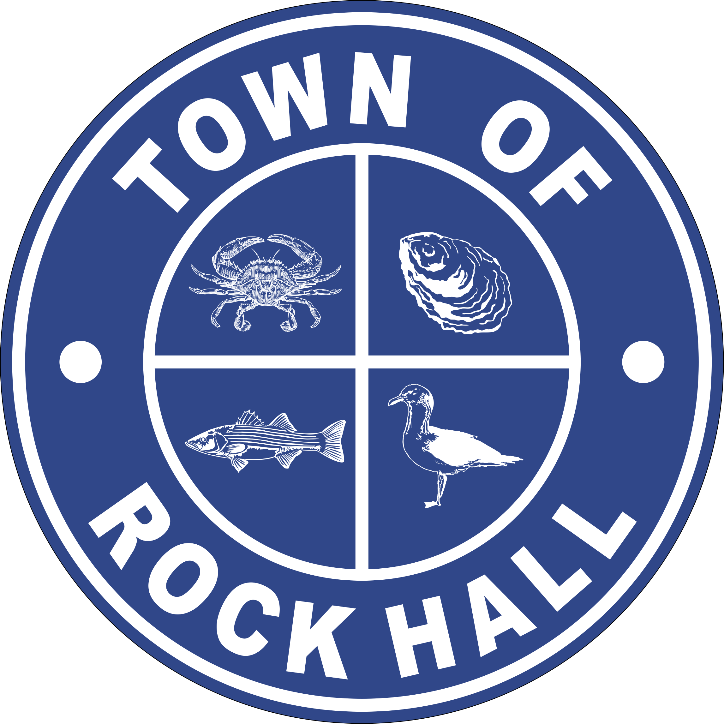

MAYOR & COUNCIL

REGULAR BUSINESS MEETING MINUTES

June 10, 2021
***Meeting minutes are transcribed in a summarized format. For full discussion and further detail of the meeting you can view the streamline video at the following link: http://townhallstreams.com/locations/rock-hall-md.
They are also available at Town Office***

Mayor Jacobs called the meeting to order at 6:06 p.m. In attendance were Vice Mayor Jones, Councilmember Cook, Councilmember Edwards (arrived late), Councilmember Collyer, Town Manager Resele, Clerk-Treasurer Loller (arrived late), and Police Chief Dempsey.

Agenda

Vice Mayor Jones made a motion to approve the agenda as amended. Councilmember Collyer seconded the motion. All in present favor. Motion carried.

Minutes

Councilmember Collyer made a motion to approve the Regular Business Meeting Minutes for May 13, 2021. Vice Mayor Jones seconded the motion. All in present favor. Motion carried.

Councilmember Collyer made a motion to approve Closed Session Meeting Minutes for May 13, 2021. Councilmember Cook seconded the motion. All present in favor. Motion carried.

Guest Update – Evan Pickering on Boy Scout Project

Evan stated that he will begin working on the renovating the Blue Heron Park on Rock Hall Avenue. He wants to power wash, replace boards and apply stain. He started out with a budget of $2,000.00 but has increased it to $3,500.00 due to the price of wood. His has set up a GoFundMe and all you need to do is go to the GoFundMe site and type in Eagle Scout Project for Evan Pickering and it will take you to his page.

Correspondence

Council read the update from Main Street Rock Hall about the directional signage project and joint project with Rock Hall Elementary School to help with the Yarn Bomb in July.

Open Meetings Act and Communication Policy review with Counsel Patrick Thomas

Mr. Thomas talked about notices for meetings, public assess for meetings and live stream and virtual meetings. A discussion followed.

Social Media by Council Members

Mr. Thomas talked about the regulations and it was decided to keep everything the same as the Council has been doing.

Administrative Reports

Clerk-Treasurer Loller gave the financial report. (*)
Police Chief Dempsey gave the police report. (*)

Streets and Sanitation

Install chain at beach to keep cars off the beach and installed signs for No Dogs Allowed on Beach and No Vehicles on Beach.

Repaired broken window at Civic Center.

Repaired water pressure issue on Rock Hall Road.

Installed underground conduit for camera at Village Restrooms.

Working with construction company for Automated Meter installations.

Installing new signs at beach to keep dog off of the beach.

Mayor Jacobs stated that the County Grant aid portion to Rock Hall is $16,869.00 which she would like to use for reopening the Brush Pile.

Mayor Jacobs also wants to get an up-to-date quote for the Civic Center drainage ditch project.

Water Operations

Chorine Scale is ordered and will be delivered next week.

Meeting with State Highway Dept. to discuss culvert replacement week of July 11th. Will set up contractor to install meter pit for new 8” meter to measure water flow to Kent County – will get quote for approval.

Meters are not received yet, except for 25 – 1” meters.

Working with State Police to get insurance information for accident on Rt 20 that damaged hydrant.

Route 20 Road Closure – Sunday, July 11, 2021 – 5:00 pm through
Friday, July 16, 2021 – 5:00 pm. Brambles will be working 24 hours a day unless there is a weather issue to repair the road by Wesley Chapel. Detours will be posted.

Sewer Plant Operations

Need to purchase 250 drying bed filter tiles to speed up dry cycle - $8,305 will be covered by ARP funding.

Effluent Pump will be completed this week.
GMB invoice for “On Call Service” to replace Headworks Screen Equipment - $14,750 will be covered in FY21 ARP funding.

Catch basket in OBT to supplement lack of Headworks filter quote -$20,500 part of MDE report to prevent “overflows incidents”. (FY22 ARP Funding)

Public Works to repair the bank on the Lagoon - $900 vs $4800 by contactor. (FY21)

Vice Mayor Jones made a motion to approve $8,305.00 to purchase 250 drying bed filters. Councilmember Cook seconded the motion. All in favor. Motion carried. (FY22)

Councilmember Edwards made a motion to approve $14,750.00 to replace the headworks screen equipment. Councilmember Cook seconded the motion. All in favor. Motion carried. (FY21)

Vice Mayor Jones made a motion to have design and prices gathered for the catch basket and the basket will be in next year’s budget. Councilmember Cook seconded the motion. All in favor. Motion carried. (FY22 ARP Funding)

Parks & Recreation

Working on getting the July 3rd Parade ready.

Next Meeting will be Monday, June 21st at 7:00 p.m.

Planning and Zoning

Copies of the monthly report were handed out to the Council.

Had a Planning Commission Meeting on Wednesday, June 9, 2021 to consider amendments to the Zoning Ordinance, Chapter 225 of the Rock Hall Town
Code. The amendments would increase the required minimum rear and side yard setbacks for accessory buildings in the R-1, R-2, and R-3 zoning districts, add a definition of the term “building footprint”, and expand, clarify, and update the types of development projects that require site plan review and approval by the Planning Commission.

There was also a presentation from the Critical Area Commission on Critical Area Map Amendments.

Museum Board

Had a meeting on Tuesday, June 8, 2021.

Robert Forloney addressed Mr. Whitman’s letter of May 27, 2021. There was a discussion afterwards.

The Smithsonian was very impressed when they came and looked at the Museum on May 24, 2021.

A $3,000.00 contribution made to the Museum Board was from the “Rock Hall Marine Restoration and Heritage Center funds.” Another $2,000.00 contribution from the Marine Restoration Funds.

Robert Forloney’s contract tables until special meeting next week.

Communication Board

All events have been posted on the .com side of the visitor page on the website.

Transportation

Nothing.

Ethics Board

Still working on putting everything together after budget.

If anyone is interested in being on the Board, please send your name to Eleanor Collyer.

Other Organization

Nothing.
Special Events Permit

Rock Hall Library – Scales & Tales Event – June 30th from 11:00am till noon.

Councilmember Collyer made a motion to approve the Scales & Tales event on June 30th. Vice Mayor Jones seconded the motion. All in favor. Motion carried.

Old Business

Bond Financing & Refinancing Line of Credit – RFP Status Update

Councilmember Collyer made a motion to accept the revisions as Counsel Patrick Thomas made and move forward with closing with Chesapeake Bank on the Line of Credit. Vice Mayor Jones seconded the motion. All in favor. Motion carried.

Resolution No. 2021-04

Issuance of a General Obligation Bond to Currently Refund the Town of Rock Hall Wastewater Facilities Bond of 10993 and Pay Issuance Costs.

Councilmember Collyer made a motion to approve Resolution No. 2021-04 regarding Issuance of a General Obligation Bond to Currently Refund the Town of Rock Hall Wastewater Facilities Bond of 10993 and Pay Issuance Costs not to exceed $635,000.00. Councilmember Cook seconded the motion. All in favor. Motion carried.

New Money Bond

Vice Mayor Jones made a motion to gather more information regarding the $800,000.00 new money bond and would the Bank still give the same rate for less new money. Councilmember Cook seconded the motion. All in favor. Motion carried.

Town Hall Evaluation and Discussion of Options

Town Manager Resele presented his finding on where to move the Town Hall Administrative offices and Police Department. A discussion followed.

Councilmember Collyer made a motion to approve payment of $1,820.00 to Sussex Environmental Council for the test they performed in the Municipal Building. Councilmember Edwards seconded the motion. All in favor. Motion carried.
There was a discussion about the mayor’s letter that she wrote and had posted on the Town’s wed site.

CDBG

Only needs 52 responses from the survey to be complete.

Hotel Tax Revenue

Nothing

American Rescue Plan (ARP) Update

Applications are due by June 30, 2021

New Business

Introduction of Emergency Ordinance No. 2021-06

An emergency ordinance for the purpose of adopting the budget and setting the real property tax rate for the Town of Rock hall’s 2022 Fiscal year; providing that the title of this Ordinance shall be deemed a fair summary and generally relating to the budget and real property tax rate of the Town. Introduced today, June 20, 2021. Pass on June 30, 2021 to become effective July 1, 2021.

Next Meeting Dates

Tuesday, June 15, 2021 – Mayor & Council Special Budget Workshop Meeting.
Wednesday, June 16, 2021 – Mayor & Council Special Budget Workshop Meeting.
Tuesday, June 22, 2021 – Mayor & Council Special Budget Workshop Meeting.
Wednesday, June 23, 2021 - Mayor & Council Special Budget Workshop Meeting.
Monday, June 28, 2021 – Utilities Board Meeting and Mayor & Council Regular Workshop Meeting.
Thursday, July 8, 2021 – Mayor & Council Regular Business Meeting.
Special Workshops – if needed – TBD

Adjournment
Motion to adjourn the Regular Business Meeting at 9:51 p.m. was made by Councilmember Collyer. Councilmember Cook seconded the motion. All in favor. The motion carried.

(*) See Town Manager’s, Financial and the Police Report for further details.

Respectfully Submitted:

______________________________
Cheryl M. Butler

Approved by:

______________________________
Dawn Jacobs, Mayor

_______________________________
Carolyn Jones, Vice Mayor

______________________________
Timmy Edwards, Councilmember

______________________________
Eleanor Collyer, Councilmember

______________________________
James Cook, Councilmember

