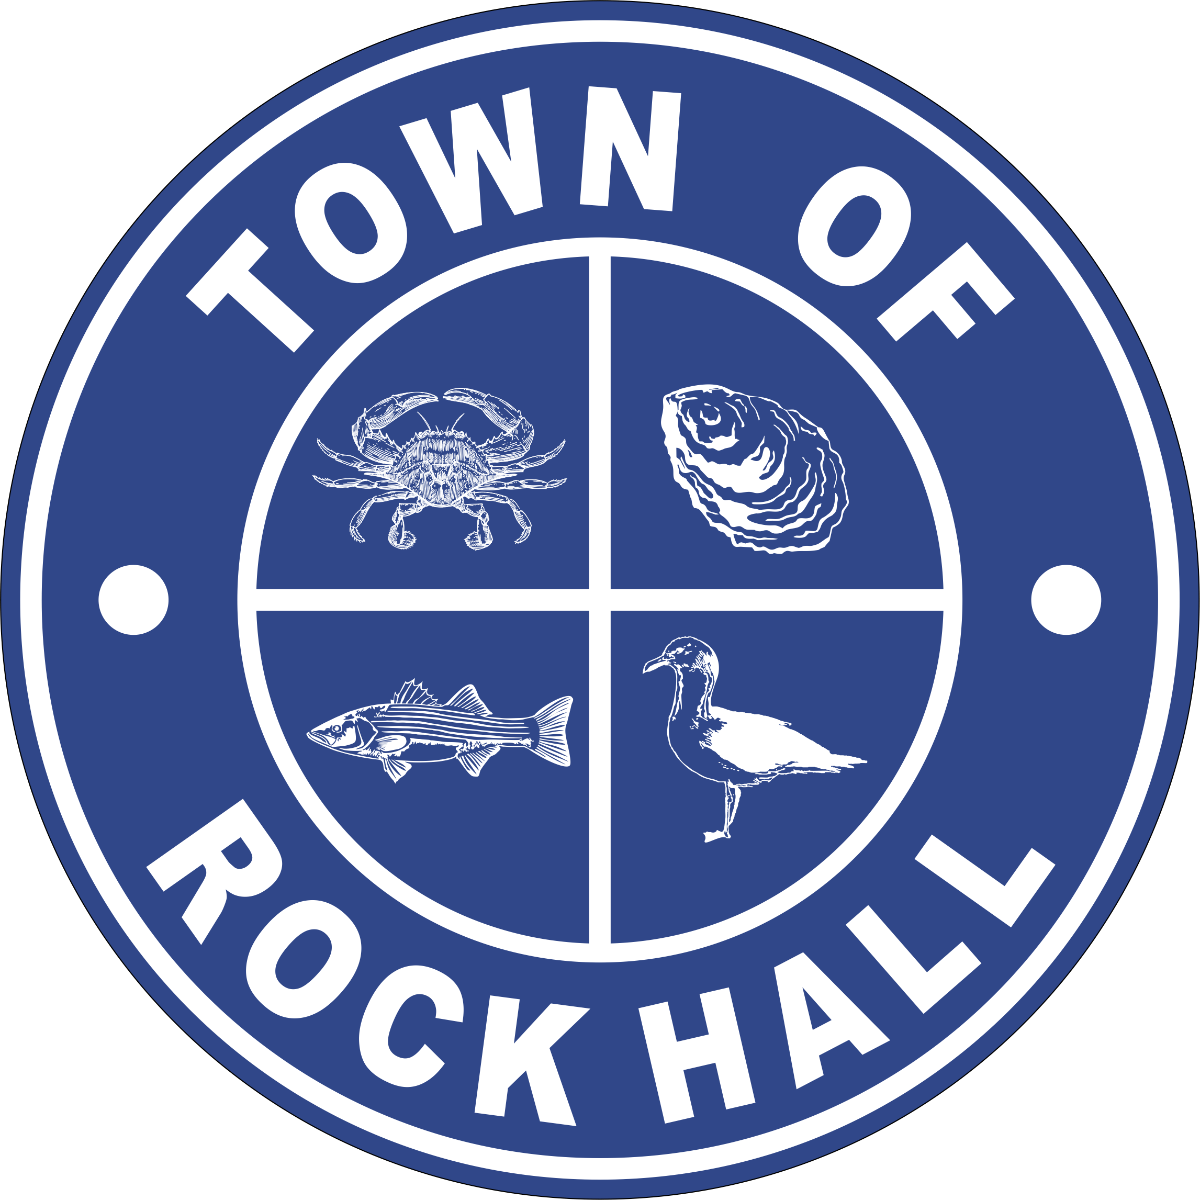

MAYOR & COUNCIL

REGULAR BUSINESS MEETING MINUTES

July 8, 2021
***Meeting minutes are transcribed in a summarized format. For full discussion and further detail of the meeting you can view the streamline video at the following link: http://townhallstreams.com/locations/rock-hall-md.
They are also available at Town Office***

Mayor Jacobs called the meeting to order at 6:00 p.m. In attendance were Vice Mayor Jones, Councilmember Cook, Councilmember Edwards, Councilmember Collyer, Town Manager Resele, and Police Chief Dempsey.

Agenda

Vice Mayor Jones made a motion to approve the agenda as amended. Councilmember Cook seconded the motion. All in favor. Motion carried.

Minutes

Councilmember Cook made a motion to approve the Regular Business Meeting Minutes for June 10, 2021. Vice Mayor Jones seconded the motion. All in favor. Motion carried.

Correspondence

Mayor Jacobs thanked the Post Office for establishing mailbox services to the 14 houses on Henry Avenue.

Administrative Reports

Police Chief Dempsey gave the police report. (*)

Mayor Jacobs thanked Chief Dempsey for all their hard work at the Parade and Fireworks.

Streets and Sanitation

Set up Town for July 4th Parade.

Painted cross walks and parking spacing lines.

Repaired water meter pit on South Main Street.

Working with construction company for Automated Meter installations.

New equipment to help with road repairs was delivered.

The Council also talked about the Brush Pile and will discuss further at the August 2nd Meeting.

Water Operations

Chorine Scale installed and calibrated.

Working with contractors to install meter pit on Route 20.

Waiting on delivery of new meters.

GMB did site visit last week for information gathering to use in PER.

Sewer Plant Operations

Effluent Pump repaired and installed.

Lagoon bank stone reinforcement continuing.

Digester blower sent out for estimate of repair.

Waiting on diffusers for digesters (back ordered).

Waiting on drying bed filter blocks (back ordered).

Parks & Recreation

Parade went well.

Going to start on the Christmas Baskets.

Want to have a couple of movie nights.

Next Meeting will be Monday, July 19th at 7:00 p.m.

Planning and Zoning

Nothing new.

Still working on getting the Website updated.

Museum Board

Mayor Jacobs stated that Robert Forloney’s contract for Phase 1 in the amount of $4,320.00 needs to be signed.
Councilmember Cook made a motion to approve the contract for Phase 1 in total amount of $4,320.00. Councilmember Collyer seconded the motion. All in favor. Motion carried.
The Museum Board has been awarded a $10,000.00 grant from MHAA.
The Museum Board was also awarded a $5,000.00 grant from The Robert Schumann Foundation to be used for Strategic Plan on Manage Museum Collections. There is an acknowledgement of receipt and consent to terms that needs to be signed.
Vice Mayor Jones made a motion to accept the grant. Councilmember Collyer seconded the motion. All in favor. Motion carried.
Museums of Kent will be granting $3,000.00 to the Rock Hall Museum.
The Smithsonian has decided they would like Rock Hall to be a host Town in their traveling exhibit April 29, 2022 through June 9, 2022.

Communication Board

Nothing new.

Transportation

Nothing.

Ethics Board

Nomination consideration will be during a Closed Session.

Other Organization

The Fire Company received a $50,000.00 grant for a Fire Rescue Boat but still needs for fund.
Kent County Parks & Recreation is doing a 5-year Comprehensive Plan update.

Special Events Permit

RHVFC Bike Fest10/23/2021 – need a county permit.
RHVFC Scrapple Festival 8am-4pm.
Reading with Dogs Kent Co Library 7/21/2021 11am to 12pm Civic Center.
Author and Illustrator Kent Co Library 7/31/2021 2pm to 3pm Civic Center.
RHVFC Rockfish Tournament 6/11 – 6/12 2022 9am to 4pm. - Canceled

Old Business
Recipients of the Repurposed Grants are:
Fresh Start, Hair Net, The Hickory Stick, Sweet Cheeks and Baycraft Printing.
Councilmember Cook made a motion to approve the grant distribution for the five businesses listed above. Vice Mayor Jones seconded the motion. All in favor. Motion carried.

Bond Financing & Refinancing Line of Credit – RFP Status Update
There was a discussion. Need to talk to Chesapeake Bank again.

Town Hall Evaluation and Discussion of Options
There will be three contractors to view site tomorrow and next week (KRM, EDiS and Willow Construction).
Kent County Library discussion about opening.
Will continue to discuss this further at the August 2nd meeting.

Grants
USDA – Streets Equipment.
$250,000.00 for the Civic Center.
CDBG – the application round will open again in August.

Hotel Tax Revenue
Mayor Jacobs talked about this but nothing happened.

American Rescue Plan (ARP) Update
Application was filed.

New Business
Introduction of Ordinance No. 2021-07 – 25% Water & Sewer Rate Increase
For the purpose of amending Chapter 102 9Fees) of the Code of the Town of Rock Hall to increase municipal water and sewer usage rates by 26 percent effective July 1, 2021; providing that the title of the Ordinance shall be deemed a fair summary, and generally relating to municipal water and sewer usage in the Town of Rock Hall.

Choptank Health Care
Mayor Jacobs talked about the Choptank Health Care coming to Chestertown and hopefully providing services to Rock Hall.

Potential Line Item FY22 Budget Adjustments
Nothing

Deferred Revenue/Restricted Cash
Tabled

EFQ – Auditors
Tabled

Next Meeting Dates
Monday, August 2, 2021 – Utilities Board Meeting and Mayor & Council Regular Workshop Meeting.
Thursday, August 12, 2021 – Mayor & Council Regular Business Meeting.
Special Workshops – if needed – TBD
Building Discussion/Plans

Closed Session

Vice Mayor Jones made a motion to recess into closed session at 9:24 p.m. under General Provisions Act. 3-305(b)(1) “To discuss the appointment, employment, assignment, promotion, discipline, demotion, compensation, removal, resignation, or performance evaluation of appointees, employees or officials over whom this public body has jurisdiction; any other personnel matter that affects one or more specific individuals.” Councilmember Collyer seconded the motion. All present in favor. Motion carried.

Actions taken: None

Adjournment
Motion to adjourn the Regular Business Meeting at 9:51 p.m. was made by Councilmember Collyer. Councilmember Cook seconded the motion. All in favor. The motion carried.

(*) See Town Manager’s, Financial and the Police Report for further details.

Respectfully Submitted:

______________________________
Cheryl M. Butler

Approved by:

______________________________
Dawn Jacobs, Mayor

_______________________________
Carolyn Jones, Vice Mayor

______________________________
Timmy Edwards, Councilmember

______________________________
Eleanor Collyer, Councilmember

______________________________
James Cook, Councilmember

