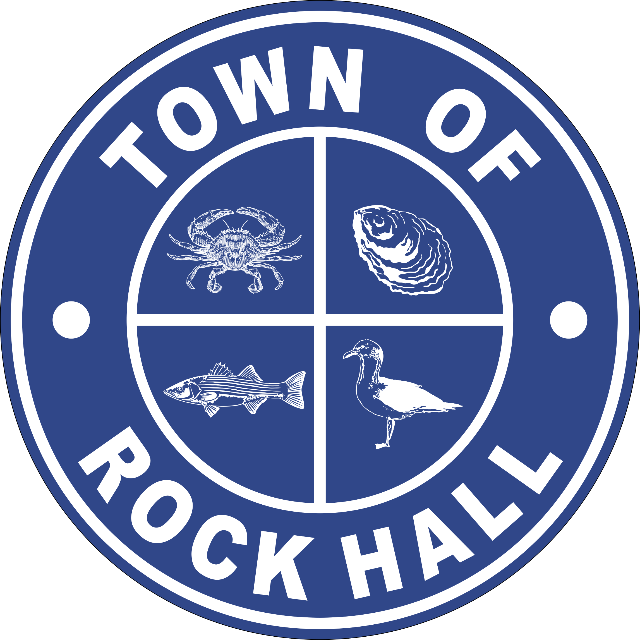

MAYOR & COUNCIL

REGULAR BUSINESS MEETING MINUTES

October 14, 2021
***Meeting minutes are transcribed in a summarized format. For full discussion and further detail of the meeting you can view the streamline video at the following link: http://townhallstreams.com/locations/rock-hall-md.
They are also available at Town Office***

Mayor Jacobs called the meeting to order at 6:00 p.m. In attendance were Vice Mayor Jones, Councilmember Cook, Councilmember Edwards, Town Manager Resele and Police Chief Dempsey. Councilmember Collyer was absent.

Agenda

Vice Mayor Jones made a motion to approve the agenda as amended. Councilmember Cook seconded the motion. All in present favor. Motion carried.

Minutes

Councilmember Edwards made a motion to approve the Regular Business Meeting Minutes for September 9, 2021. Vice Mayor Jones seconded the motion. All in present favor. Motion carried.

COVID Update

The Rock Hall Fire Company will be having a Drive-thru Flu Shot only on Wednesday, October 20, 2021.

Correspondence

Kent County Commissioners invited the Council to attend a hearing presented to discuss Maryland Department of Transportation consolidated Transportation programs for the upcoming year on October 28, 2021 at 10:00 am.

Laurie Walters from MainStreet Rock Hall presented the Mayor and Council a donation check in the amount of $2,000.00 from the Pirates & Wenches Committee for the support the Town shows during this weekend.

Sharon Truitt, Joe Curley and Dr. Michael Pimer spoke on behalf of the Hospital and the need for Community support.

A resident on East Sharp Street wants a 6-month special temporary permit for use of a travel trail while renovating his house. Town Manager Resele will talk to Legal.

Administrative Reports

The Financial Report was tabled.

Police Chief Dempsey gave the police report.

Streets and Sanitation

Automated Meter installations – received new tablets and coding equipment.

Flushing of Water Lines.

Painting of curbs to match “No Parking”.

Fallfest support.

Water Operations

New Bulk Tank installed.

Cleaned Clarifier tank.

Put meters in the AMI software.

Sewer Plant Operations

ProStart working with team.

Digester #3 90% complete.

Parks & Recreation

Friday Night Movie Night showing Casper will be held on Friday, October 19, 2021 at the corner of Bayside Avenue and Caroline Street.

Saturday night, October 30, 2021 – Truck or Treat at the Rock Hall Fire Company from 4-6 pm.

Sunday night, October 31, 2021 – Trick or Treat in the Town from 5-7 pm.

Bocce Ball league at the Civic Center – will find out more details.

Working on the Christmas Basket Tree. All new baskets will need to be done this year and you must paint your own.

Saturday, December 4, 2021 will be Santa’s arrival at the Bulk Head to Main Street and the Basket Tree lighting.

Next Meeting will by Monday, October 18, 2021 at 7:00 pm.

Planning and Zoning
Review of at General Code. Confirm that the $10,500 quote includes only codifying the zoning, subdivision, and floodplain documents.
Mayor Jacobs talked about the Glamping and Kent Center House on Lee Street.
There were public comments at this point.

Museum Board

Application for a new member – Adrienne Hicks

Councilmember Cook made a motion to approve the application for Adrienne Hicks to be a member of the Museum Board. Vice Mayor Jones seconded the motion. All present in favor. Motion carried.

Cathy Bramble requested the artifacts stored at the Sewer Plant back that were on loan to the Town of Rock Hall to a site at Tolchester Marina. They will be displayed in an environment friendly area.

Councilmember Cook made a motion to authorize the Museum Board to remove the artifacts mentioned in the Sewer plant and moved to Tolchester Marina as a loan which is a formal agreement between the Museum Board and Tolchester Marina. Vice Mayor Jones seconded the motion. All present in favor. Motion carried.

The Museum Board voted to start the process for a 501C3 but stopped. They are now requesting an RFP to hire an expert to see if a 501C3 is right for the Museum Board.

Councilmember Cook made a motion to move forward with the RFP for the Museum Board. Vice Mayor Jones seconded the motion. Mayor Jacobs abstained from the vote. All present in favor. Motion carried.

Communication Board

Nothing new.

Transportation

Nothing new.

Ethics Board

Nothing new – still working on it.

Other Organization

Kent County Commissioners approved the Rock Hall application as an Enterprise Zone.

At the COGS Meeting there was a discussion about the Choptank Health Care Systems which is establishing a facility in Chestertown and will be putting a mobile unit in place that will come to Rock Hall to provide basic medical services.

Special Events Permit

Nothing

Old Business

Town Hall Options Update
Meeting to Council week of October 19, 2021.
New Lease signed Wyble Building.
ARPA budget.
Off Site Scanning of Documents.
Dump Truck sold for $4,000.
Purchase mini excavator.
Current rental $1,700 per month.
Purchase Dump Truck.

New Business

Potential Line Item FY22 Budget Adjustments

Tabled until Workshop Meeting.

Next Meeting Dates
Monday, November 1, 2021 – Utilities Board Meeting and Mayor & Council Regular Workshop Meeting.
Thursday, November 11, 2021 – Mayor & Council Regular Business Meeting.
Special Workshops if needed – TBD
Building discussions/plans
Financing & Refinancing Discussion
Grants

Closed Session

Councilmember Cook made a motion to recess into closed session at 8:45 p.m. under General Provisions Art. 3-305(b)(1) “to discuss the appointment, employment, assignment, promotion, discipline, compensation, removal, resignation, or performance evaluation of appointees, employee, or officials over whom this public body has jurisdiction; any other personnel matter that affects one or more specific individuals”. Vice Mayor Jones seconded the motion. All present in favor.

Actions taken:

There were no actions taken.

Adjournment
Motion to adjourn the Regular Business Meeting at 9:08 p.m. was made by Councilmember Edwards. Councilmember Collyer seconded the motion. All in favor. The motion carried.

Respectfully Submitted:

______________________________
Cheryl M. Butler

Approved by:

______________________________
Dawn Jacobs, Mayor

_______________________________
Carolyn Jones, Vice Mayor

______________________________
Timmy Edwards, Councilmember

______________________________
Eleanor Collyer, Councilmember

______________________________
James Cook, Councilmember

